**Beet Seed 1**

Requirement 1:

When the user click “Create account” after entering their email and creating a password, an email is sent to the email used for the account with a link for account verification.

Requirement 2:

When creating a user name, if the name chosen by the user is already being used, show the message “User name is already being used. Please choose another user name” on top of the User Name field.

Requirement 3:

After login in, the user is directed to its personal profile in 5 sec max

**Beet Sprout 2**

For the highest quality of the final products, the best way to assess the requirements is, in my opinion, the question technique.

By questioning the customer and/or the end user about the product requirements, it is easier to know how each part of the product should function and how these parts interact with each other to produce a product that is in line with what the customer wants and how the user will use the product.

Instead of guessing what the client wants with a certain unclear requirement, asking the client directly is the easiest way to understand exactly what they want.

**Mighty Beet 2**

Functional

* When opening the app (on Android/IOS), there must be two buttons on the center of the screen; one for the user to login, with the text “Log in” and other for the user to register with the text “Don’t have an account? Sign up here”.
* When signing up, the user must be able to create an account using an email address or a social media account (Instagram, Facebook or Pinterest).
* The user must be able to upload photos of cats (in .jpeg or .raw format) directly from their mobile device, either using the device camera or images from the device’s gallery.
* On the user’s profile the uploaded photos must appear in chronological order of upload, in a scheme of 3 photos per row.
* When viewing its own profile there must be a button labeled “Following” that, when clicked, should take the user to a list of other profiles that they are following.

Non-Functional

* The user’s information, its uploaded images and account must be stored in a secure manner and protected against unauthorized access.
* During the upload of the pictures, there must be a field for users to input alternative text; this field can le left blank.
* On the “Definitions” there must be a field labeled “Notifications”; in there there must be an option “Turn off all notifications”.
* When the user uses the search bar there should appear suggestions of other accounts, based on what the user is typing, as the user types.
* When clicking on the app icon on the device’s menu, the app should open in 5 sec max.

**Extra Task**

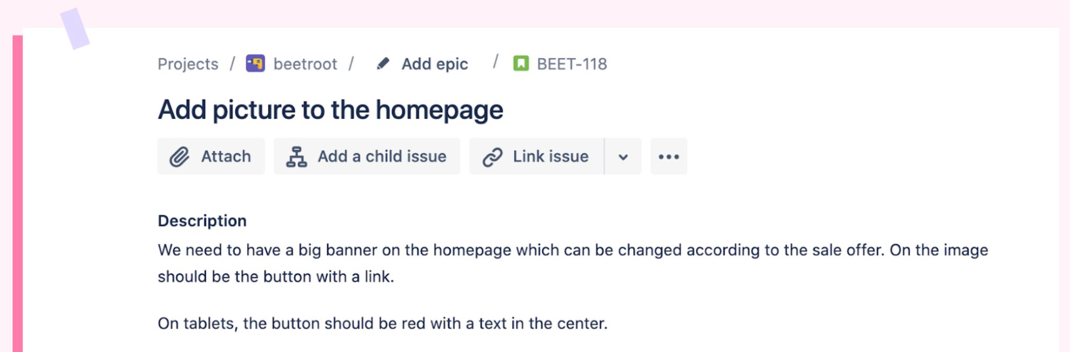

User’s story

As a Content Manager, I should be able to change the big banner on the homepage, so that the picture is in accordance with the sales offer happening at the moment.

Acceptance Criteria

* There should be an option for the Content Manager to change the picture on the banner
* There should be a button with a link on the image
* The link on the button should be changeable by the Content Manager
* On tablets the button should be red with a text in the center; the Content Manager should be able to change the text on the button